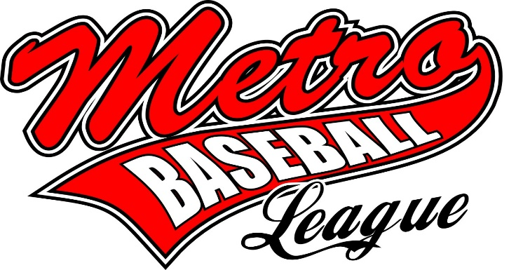

MBL Fall Ball COVID-19 Guidelines/Safety Plan
**Please Note**
The below plan has been created to serve as an overall guideline of protocols for practices and game days during the MBL Fall Ball season.
However, ANY HOST ASSOCIATION with a different COVID-19 plan will supersede MBL if they wish.

COVID-19 screening and policies for participants:
Participants are required to self-monitor for signs and symptoms of COVID-19 before leaving home. Stay home if you have a temperature exceeding 100.4 or have respiratory symptoms (i.e. cough, sore throat, or shortness of breath).
Participants who are sick should notify their Program Director and follow CDC-recommended steps. Participants should not return to play until the criteria to discontinue home isolation are met, in consultation with healthcare providers and state and local health departments.
Participants who are well, but who have a sick family member at home with COVID-19 are required to follow CDC recommended precautions including self-quarantine and will not be allowed to participate in MBL Fall Ball activities until the self-quarantine guidelines have been met.
Participants with underlying medical conditions or who have household members with underlying health conditions should take additional precautions to minimize face-to-face contact and/or use CDC approved Personal Protective Equipment (PPE) if possible.

Reporting:
If a participant is confirmed to have a COVID-19 infection- The respective coach of that team must be notified and a team representative will inform fellow participants of their possible exposure to COVID-19 while maintaining confidentiality and instruct fellow participants about how to proceed based on the Public Health Recommendations for Community-Related Exposure. A team representative must also email Betsi Sherman at Betsi@mbl.bz to report the confirmed infection for our file.

Before the Games:
• Players should arrive to and depart from their assigned fields in a timely fashion.
• If players wish to congregate this should be done offsite or away from the game fields. Players must adhere to 6-foot physical distance at all times when not playing games.
• Players should bring their own personal sports equipment.

During the Games:
• Players must adhere to 6-foot physical distance in the dugouts; players can spread out down the foul line beyond the dugout during the batting half of the inning.
• No sharing of any food or beverages. No spitting, sunflower seeds, etc.
• Players should avoid sharing equipment whenever possible.
• Players should refrain from touching their face (eyes, nose, and mouth).
• Players are encouraged to bring their own hand sanitizer. Hand sanitizer should also be available in each dugout, its use is strongly encouraged before and after each game, and whenever equipment (bat) is shared.
• Players, managers and umpires must refrain from unnecessary contact. This includes high-fives, handshakes and fist bumps.
• The umpire will be positioned behind the pitcher to call the game.
• Wearing a face covering when not participating in a game is strongly encouraged, but not mandatory for all players, coaches, umpires and spectators (this includes bench personnel).
• All spectators must adhere to physical distancing (6-foot distance between households)

After the Game:
• Players and spectators should leave the fields immediately following their games and not congregate.

Cleaning and disinfecting:
Regular housekeeping practices should be followed including routine cleaning and disinfecting of player equipment. Team personnel will carry disinfectant to be used before, during, and after practices and games. Players should refrain from sharing equipment when possible and sanitize immediately after if shared.
• Coaches will sanitize surfaces in the dugout upon arrival and after each practice or game.
• Teams should clear their dugout/bench area of all trash and other items after each practice or game.
• Players should use their own personal cooler. Water bottles and coolers should be clearly labeled with the players first and last name. Team coolers are prohibited.
• Participants should hand sanitize following contact with other players, coaches, or shared equipment.

Other information:
- Face masks are recommended, but not required with proper social distancing guidelines enforced.

- Teams and spectators will be required to vacate the park once their games have been completed.

- Teams will be asked to not spectate other games that are occurring.

- Parents and spectators will have separate seating away from the players and extended dugout areas. The spectator area will generally be down the 1st/3rd base lines beyond the dugouts and in the outfield areas on most fields. On some fields where the field access doors are on the outfield side of the dugout, the spectator area may instead be located behind the backstop.

- Spectators will not be allowed around the area of the extended dugouts.

- Only players, up to three coaches per team and the umpire(s) are allowed on the field of play.

- Only immediate families/households of the players will be allowed to spectate games. Attendees will need to sit with their family unit. This means that all family members will need to distance from all other family units.

This guidance is based on the MDH Guidance for Social Distancing in Youth and Student Programs.

Communications and training:
This Preparedness Plan will be communicated to all participants on or before the first day of organized activity. Additional communication and training will be provided to all participants on an ongoing basis as necessary to accommodate any changes and the plan will be updated accordingly.

